**9V Smart Battery Proposal**

**Alicia Lawrence, Barak Barclay, Brian Griffen, and Chris Sherwood**

**Lindsay Kopps at EM Microelectronic**

**Dr. Byeong Lee**

**ECE4890/4891**

**05/13/2019**

Table of Contents

Problem Overview [written by Brian Griffen & Barak Barclay] 3

Problem Statement [written by Brian Griffen] 3

Standards Discussion [written by Brian Griffen] 4

Constraints Discussion [written by Brian Griffen] 4

Economic 4

Environmental 4

Social 4

Political 5

Ethical 5

Health and Safety 5

Manufacturability 5

Sustainability 5

Requirements Analysis and Literature Search [written by Barak Barclay & Alicia Lawrence] 5

Requirements Specification [written by Barak Barclay & Chris Sherwood] 8

Team Organization [written by Barak Barclay, Alicia Lawrence, Brian Griffen, & Chris Sherwood] 10

Team Constraints [written by Barak Barclay, Alicia Lawrence, Brian Griffen, & Chris Sherwood] 10

Operational Description [written by Chris Sherwood] 11

Block Diagram [written by Chris Sherwood] 11

System Design Expectations [written by Alicia Lawrence] 12

Draft Budget [written by Alicia Lawrence] 12

Deliverables [written by Chris Sherwood] 13

Appendix [written by Dr. John Lindsey & Lindsay Kopps] 13

Compiled By … [Barak Barclay, Alicia Lawrence, Brian Griffen, & Chris Sherwood via Office 365] 13

# Problem Overview [written by Brian Griffen & Barak Barclay]

The 9V Smart Battery problem addresses the issue of not having a convenient way of knowing when a 9V battery is about to die. 9V batteries are used in many different household items such as smoke alarms, garage door keypads, multimeters, and various toys. Smoke alarms chirp when the battery low, but the chirping can wake people up in the middle of the night and in some houses, it can be hard to find which smoke detector’s battery is going out. Some devices may die without anyone knowing and can cause other issues such as being locked outside in the cold when your keypad does not work, or a logging multimeter dying while a test is in progress

The objective of the 9V Smart Battery is to solve the inconvenient issues that come with dying batteries by alerting the user with ultra-low power wireless communications that the battery is going to die. The key issues include creating a prototype that is small enough to fit in a 9V battery case and designing a circuit that does not significantly reduce the battery’s lifetime. There are products on the market for determining a battery’s remaining lifetime but there are no designs that alert the user with the EM9304, the module our customer wants to use, that a 9V battery is near the end of its lifetime.

# Problem Statement [written by Brian Griffen]

The requirements as agreed on with our customer are detailed below. These are to assure that the design will be practical by fitting in the same area as a 9V battery, that the battery still has a reasonable lifetime, that the alert can be seen at a reasonable distance, and that their product will be used in the design.

* The design deliverable must be on a working PCB
* The bill of materials cost in bulk must be cheap
* The design must use EM Microelectronics' EM9304 to transmit the alert
* The circuitry for the design must not reduce the batteries lifetime significantly
* The design must be able to alert the user at a large distance outdoors in order to be useful in an indoor setting
* *Stretch:* The design PCB should fit in the dimensions of a typical 9V battery
* *Stretch:* The design should have a smartphone application to complement it by alerting the user, allowing certain devices to be named, and allowing the user to snooze the alerts.

**Conflicting Customer Needs:**

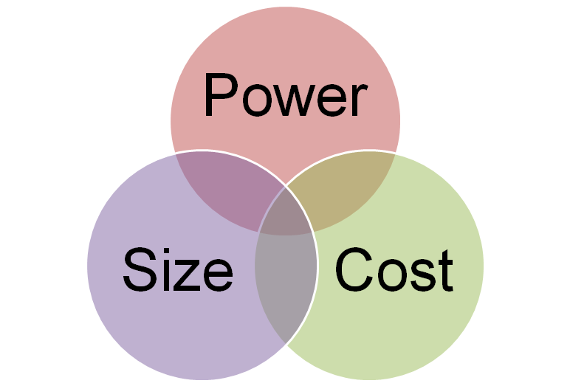

The design needs to be low power, small, and cost efficient. However, these customer needs conflict with one another and need to be balanced.

# Standards Discussion [written by Brian Griffen]

There are several standards that need to be addressed while for the design that are discussed below:

* ANSI 1604 – This standard gives example loads that a battery must be able to handle. Since the solution is for 9V batteries these reference loads are very useful for testing. The example loads include a toy load of 270 ohms, a radio load of 620 ohms, and a smoke detector load of 43 kilohms with a 620 Ohm pulse load once an hour for 1 second. This spec also gives a 9V battery’s dimensions that apply to the stretch goal size.
* E-CFR 15.249 - This standard is from the Federal Communications Commission that allows commercialized products to advertise in the Bluetooth range of 2400 to 2480 MHz. This has already been certified by EM Microelectronic.
* Bluetooth 5.0 - This is the standard by the Bluetooth Special Interest Group that dictates the format of Bluetooth compatibility. This has already been certified by EM Microelectronic.
* UL 268 – This is the standard for smoke alarms in stationary homes. The 9V Smart Battery is general purpose and not to be used in life-saving devices.
* UL 217 – This is the standard for smoke alarms in mobile homes. The 9V Smart Battery is general purpose and not to be used in life-saving devices.
* NFPA 72 – This standard is for smoke alarm design in the United States. The 9V Smart Battery is general purpose and not to be used in life-saving devices.
* EM9304 SOC SDK 6.0 - This is the standard for programming the EM9304. It includes a Getting Started Guide, an Implementer’s Guide, and all the software tools, development files, and libraries required for the EM9304.
* EM9304 – The standards for the EM9304 include the QFN-28 packaging and use of Bluetooth 5.0 Low Energy Technology.
* Voltage Monitoring – TBD
* Voltage Converting – TBD
* Battery Composition or Battery Choice – TBD

# Constraints Discussion [written by Brian Griffen]

## Economic

For this project the team must adhere to a non-recurring engineering cost between $500 and $1000. The bulk bill of materials cost at 10,000 units must be less than $5.

## Environmental

For this project the design will only be using non-rechargeable batteries so more batteries will be disposed of because the non-rechargeable batteries will be discharged faster with the additional circuitry.

## Social

For this project there are no social constraints. The project does not involve any communication or interaction between individuals.

## Political

For this project the team must adhere to the FCC’s standards discussed above as advertising on illegal channels would result in consequences.

## Ethical

For this project there are no ethical constraints. The design should not harm any individuals or the environment.

## Health and Safety

For this project it is important to communicate that our solution is general purpose only as there are consequences for tampering with a device like a smoke alarm or carbon monoxide alarm. The design also shouldn’t interfere with a 9V battery-operating device’s ability to send its own low-battery alerts.

## Manufacturability

For this project the team must adhere to the bulk bill of materials cost and use smaller parts to chase the stretch goal. This would make the manufacturing more difficult as smaller components mean finer equipment to build the product.

## Sustainability

For this project the sustainability of the design should be sturdy and make sure that the battery does not need to be constantly replaced.

# Requirements Analysis and Literature Search [written by Barak Barclay & Alicia Lawrence]

Understanding the problem started with getting to know the customer, Lindsay Kopps. After the first meeting, it was determined that she’s an informed customer. As an informed customer, she understands what she wants which makes getting requirements and constraints straightforward but leaves little leeway for any changes.

The Roost 9V Specialty Battery is an example of how this problem is solved by others. Based on the FCC breakdown for this product, their voltage monitoring system looks like it monitors the beeping of a smoke alarm rather than the battery voltage itself which would not be suitable for our system. Our system needs to monitor the voltage of the battery rather than the beep of a smoke alarm so that it can be a general use device and give the user the convenience of being notified via Bluetooth before the smoke alarm starts chirping.

To develop the requirements specification and determine viable options for designing our circuit, research and analysis was done on the three parts of our problem shown in the block diagram below:

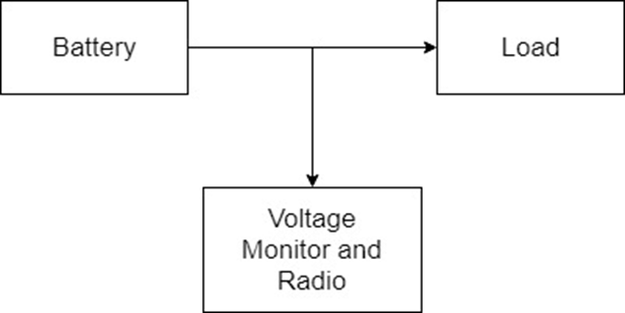

**Load:**

The ANSI 1604A test specification has various loading conditions that need to be considered. A 9V smart battery won’t likely be used in devices with smaller loads, like a toy, but those devices still need to be considered. For instance, if the circuit samples the battery voltage at irregular intervals using a dynamic algorithm, the battery could die before a Bluetooth transmission is sent. If the smart battery is designed this way, we may have to specify a load range.

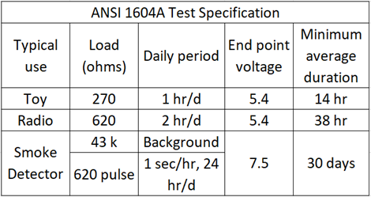

On the other end of the load spectrum, the greater the load, the bigger impact the circuit will have on the battery's life span. Since smoke detectors fall on this side of the loading spectrum and have other properties to examine, measurements were taken on the First Alert SA303 smoke detector.

The SA303 has an average idle current of 13.88uA. It also starts chirping when the battery reaches 7.5V. So, the smart battery needs to start sending Bluetooth transmissions before then. We also saw some intermittent loading of a 0.1V voltage dip every time the LED turns on. Intermittent loading is an important consideration in our design so the EM9304 isn’t advertising on false positives.

**Battery:**

|  |  |  |  |  |  |  |  |
| --- | --- | --- | --- | --- | --- | --- | --- |
| **Circuit Response** | **Battery Capacity** | **Lithium Voltage (V)** |  |  | **Alkaline Voltage (V)** |  |  |
|  |  | Max | Min | Delta | Max | Min | Delta |
| Sample Voltage | 100% to 75% | 9 | 8.5 | 0.5 | 9 | 7.8 | 1.2 |
| Advertise Alert | 75% to 50% | 8.5 | 8.5 | 0 | 7.8 | 7.2 | 0.6 |
| Device Alert | 50% to 25% | 8.5 | 8.1 | 0.4 | 7.2 | 6.5 | 0.7 |
| Battery Dead | 25% to 0% | 8.1 | 5 | 3.1 | 6.5 | 5 | 1.5 |

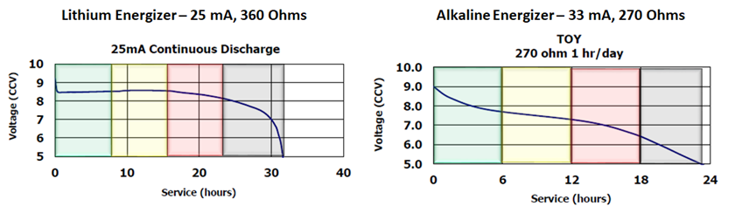Lithium and alkaline batteries have different capacities and discharge curves that need to be considered as well. Lithium batteries have a larger capacity that affects the device lifetime; however, they cost more and stay closer to 9V until they’re about to die. Even though alkaline batteries have a smaller capacity, we are leaning more towards designing with alkaline since the circuit won’t need as much resolution and will make the device more cost efficient to build.

**Voltage Monitor and Radio:**

The EM9304 module operates at 1.5V and 3V, so a voltage regulator is required to step-down the voltage from 9V. Our design also needs a way to monitor the battery voltage so that the EM9304 can start sending Bluetooth transmissions when the battery gets low. The two main methods of doing this are using an ADC or a voltage supervisor. An ADC can monitor the battery’s voltage periodically and send the voltage samples back to the EM9034. A voltage supervisor would allow EM9304 to remain off and only turn on when it senses that the voltage has dropped below a set threshold. Another method to monitor the battery’s capacity would the use of a Coulomb counter. If we decide to go with a lithium battery, it may be the better way to go since it constantly monitors the current the circuit is using to track amp-hours rather than monitoring the voltage. However, coulomb counters generally have higher current consumption than ADCs and voltage supervisors. We’ve also looked into the joule thief circuit which would keep the voltage at a steady 9V even at the end of the battery life to use nearly all the energy in the battery cell. However, that would interfere with a 9V battery operating device’s ability to send out their own indication that the device is low.

The EM9304 also has different TX power levels that affect the transmission range. However, distance comes at the cost of additional power consumption. It also has different states that the device can operate in, including a 1uA sleep mode, 5nA disable mode and a 5.2mA peak current at 0.4dBm in transmit mode. Using these states at appropriate times will also help keep the power consumption low. The EM9304 also has an SDK that uses the Metaware IDE and embedded C programming. It has 128kB of OTP memory that will limit our max code size.

|  |  |  |  |  |
| --- | --- | --- | --- | --- |
|  | **RAIL**  **VOLTAGE (V)** | **MIN** | **TYP** | **MAX** |
| EM9304 Transmit Current (mA) | 3 | 2.2 | - | 9.9 |
| EM9304 Sleep Current (µA) | 3 | - | 1 | - |
| EM9304 Chip Disable Current (nA) | 3 | - | 5 | - |
| Battery Sense Bias Current (µA) | 9 | - | TBD | - |
| Battery Sense Average Current (µA) | 3 | - | TBD | - |
| Voltage Regulator Quiescent Current (µA) | 9 | - | TBD | - |

# Requirements Specification [written by Barak Barclay & Chris Sherwood]

**Requirements:**

The demonstration unit must utilize the EM9304 module and include a hardware design to substitute the 9V battery or add onto the 9V battery to work with existing 9V battery operating devices. The unit price must be less than $5 at 10,000 units, and it should reduce the battery’s life by less than 20%.

**Specifications:**

|  |  |  |  |  |
| --- | --- | --- | --- | --- |
|  | **Operating Value** | **MIN** | **TYP** | **MAX** |
| Power Supply (V) | - | 6 | - | 9.5 |
| System Voltage (V) | - | 1.5 | - | 3 |
| Average System Current (uA) | 3 V | - | - | 10.5 |
| Advertising Interval (Hz) | - | - | 0.5 | - |
| Advertising Duration (Days) | 17.5 uA | 10 | 14 | - |
| Transmission Range Open Air (m) | - | - | 50 | - |

**Test Plans:**

The power consumption of our design will be characterized across the full supply range and in all operating modes using a power supply and ammeter in place of the battery as shown below. The power supply voltage will be swept from the specified high battery voltage to the low battery voltage, and the average current measured. The device will be put into its different states (e.g. low power, processor active, Bluetooth transmit, etc) and the voltage swept in each state. Bluetooth transmission current will be characterized by the device in a constant (non-pulsed) transmission state. The device will also be functionally verified by monitoring a serial output stream in active and transmitting states to validate correct microcontroller operation across the full operating voltage range.

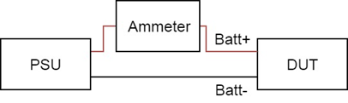

The transmit range of the EM9304 will be verified using the nRF Connect application on an Android phone placed a distance of 50 m from the device in an open field or parking lot with no obstructions. The EM9304 and Android devices will be oriented in fixed positions, taking care to avoid possible polarization mismatch issues. The Bluetooth output power will be varied in programming, and a Bluetooth beacon transmission will be made at a regular interval. The received packets will be monitored in the nRF Connect application for dropped or incorrect data to determine the lowest acceptable transmission power level which still achieves the 50 m specification. 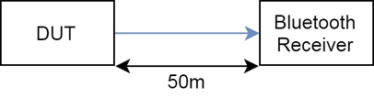

End of life functionality will be verified by running the device from an artificially discharged battery. The battery will be rapidly discharged to just before the alert threshold, and the device under battery power will be attached to a smoke detector-type load. Using a Bluetooth packet sniffer, the device will be monitored for alert beacon transmissions, and the received transmissions will be timestamped and recorded until the device is no longer functioning. The advertising duration will be determined as the time difference between the first and last received beacon transmissions. 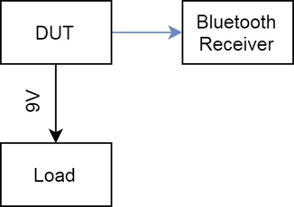

Correct advertising interval will be verified using a Bluetooth packet sniffer capable of timestamped logging. The device will be placed into a low-voltage Bluetooth alert state, and the device monitored for Bluetooth beacon transmissions. The sniffer will log and timestamp the transmissions as they are received, and the advertising interval will be determined as the average of logged intervals over a set period of time.

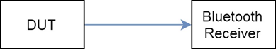

# Team Organization [written by Barak Barclay, Alicia Lawrence, Brian Griffen, & Chris Sherwood]

Project & Communications Manager: Barak Barclay

Finance & Logistics Manager: Alicia Lawrence

Design Manager: Brian Griffen

Test Manager: Chris Sherwood

# Team Constraints [written by Barak Barclay, Alicia Lawrence, Brian Griffen, & Chris Sherwood]

Barak Barclay (CpE): As a computer engineer, I’ve been exposed to more software development in my courses than the rest of my teammates. However, the only embedded programming experience I’ve had is the microcomputer systems lecture and labs. I’ll be taking embedded systems in the Fall. I’ve had experience with intensive programming algorithms which may help, depending on how we design the circuit. I’ve also had a good amount of experience with hardware, circuit design, and using measurement tools from my EE courses. With that, I’ll be helping my team with the circuit design as well. After we finish the embedding programming, I plan on working on our stretch goal of developing a Bluetooth mobile application. I’ve never developed a mobile application before, but I believe I’ve gained the skills over the course of my education to teach myself how to do so. Along with this project, I have other plans I hope to accomplish including continuing the sci-fi story I started writing a couple of summers ago.

Alicia Lawrence (EE): As an electrical engineer, I am more skilled in the hardware part of this project compared to the software end. I’ve had experience with circuit design and layout throughout my degree and it’s something that I’ve enjoyed the most. Although hardware would be considered my “specialty”, I feel that I am at a disadvantage because I have no experience in the industry. The other electrical engineers on my team have internship/job experience in the engineering field and tend to know a lot more about hardware than a degree can teach. Thankfully, I am learning a lot being a part of such an experienced group of people and will continue to apply what I learn to my future endeavors. I am very interested in software but have had little time to teach myself more than the little bit of C, Verilog, and MATLAB that our degree offers. After graduation, I hope to expand my knowledge of software as well as get more experience in the electrical engineering field as an intern or entry level engineer.

Brian Griffen (EE): From school, the relevant topics I am experienced in are computer architecture and control systems. These areas should be very useful further into the project in understanding how the EM9304 works as well as providing an alternate design. I work at the sponsoring company so I also bring familiarity with the microcontroller we will be using as well as the test equipment at EM. My job has given me experience in Python, automating measurement instruments, schematics and PCB design, debugging, and testing. I am not experienced with embedded C or any other low-level languages. After graduation I plan to continue working at EM Microelectronic as a verification engineer or FAE.

Chris Sherwood (EE): I have some prior coursework in C development, microcontrollers, and antenna theory, as well as prior work experience in circuit design and layout, data collection and analysis, system troubleshooting, and test development. With regards to this project, I am lacking in embedded C experience, very low-power system design, and wireless communications. After graduation I expect to continue full-time at Cobham as an engineer, while also potentially pursuing a master’s degree. I currently have tighter time constraints due to my combined work and course load.

# Operational Description [written by Chris Sherwood]

The device will monitor the status of an attached battery and will notify a user with a Bluetooth beacon when the battery reaches a predetermined charge level. The device will do this without user intervention, starting when the device is connected to battery power and ending when the battery is dead.

As part of the stretch goal of a packaged, consumer device, there will be some way for the integrated battery to be disconnected from the rest of the circuit, either prior to sale or while generally not in use, to minimize power consumption while not in use. This will require the end user to “turn on” the circuit prior to insertion into another device.

If a dedicated mobile application is developed, this application will have a way to individually identify unique devices with an arbitrary name. This will require a way to force the circuit to either enter a paired Bluetooth connection, broadcast a Bluetooth beacon by pressing a button or entering a device ID on the application side.

# Block Diagram [written by Chris Sherwood]

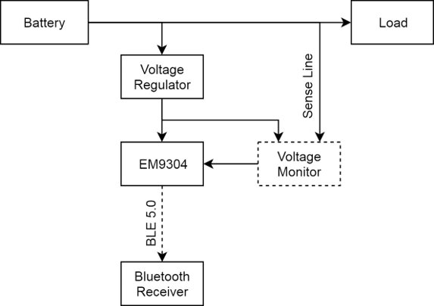

# System Design Expectations [written by Alicia Lawrence]

We need to design a system using the EM9304 that monitors the status of the attached battery and notifies the user at an interval of 0.5 Hz via Bluetooth beacon when the battery has reached a predetermined charge level. This charge level should be before the battery is completely dead and before the battery becomes an issue and/or annoyance to the user (e.g. beeping or low battery notification) as determined by the load. Since our system needs to be battery powered, we need to ensure that our design is low powered enough to only reduce the battery life by 20% or less as required by the customer.

Developing a fully-functional prototype that accurately determines low voltage within the requirements and power constraints is what is expected at the end of this project. The availability of parts that fit within the power constraints (low standby and quiescent current) can have a big impact on this design. With initial research into materials, there are only a handful of ultra-low powered parts that operate in the required voltage range (9V and 3V). Another big impact is the cost of materials. The customer requires a maximum unit price of $5.00 per 10,000 units. We must ensure the materials used not only fit within the power constraints, but also the budget which may limit availability even more.

# Draft Budget [written by Alicia Lawrence]

There are two different budgets for this project. The first being the project budget. The project budget will cover the purchase of materials for the prototypes as well as any other materials required for research (e.g. competitor products). The customer gave us a project budget of $500 - $1000. Based on the current system diagram, the following needs to be purchased:

|  |  |  |
| --- | --- | --- |
| **List of Materials** | **Qty** | **Avg. Price** |
| 9V Battery | 10 | $50.00 |
| Voltage Regulator | 10 | $30.00 |
| Voltage Detector | 10 | $20.00 |
| PCB | 4 | $120.00 |
| Roost (competitor product) | 2 | $70.00 |
|  | Total: | $290.00 |

With an estimated shipping cost of $100 for all the products, we plan to spend roughly $400 in materials to build the prototypes and further research. Some companies are willing to send free parts to students which could bring costs down even more. Thankfully, EM Microelectronic will provide the EM9304 for the prototype build with no cost to us.

The other budget is the bill of materials for the system. The customer requires a maximum unit price of $5.00 per 10,000 units for the entire system. This includes the battery, voltage regulator, voltage detector, EM9304, and PCB. The table below lists the materials and estimated cost for each per 10,000 units.

|  |  |  |
| --- | --- | --- |
| **List of Materials** | **Qty** | **Avg. Price** |
| 9V Battery | 10K | $2.00 |
| Voltage Regulator | 10K | $1.00 |
| Voltage Detector | 10K | $0.75 |
| EM9304 | 10K | $0.90 |
| PCB | 10K | $0.15 |
|  | Total: | $4.80 |

With that estimated bill of materials, we are just below our maximum at $4.80 per 10,000 units for the entire system. The cost of the battery is something that will need to be taken into consideration when developing this system as it is the most expensive part. Once the 9V battery type (alkaline or lithium) is chosen and the prototypes are built, it will give a better idea of what parts are preferred and a more accurate bill of materials.

# Deliverables [written by Chris Sherwood]

The following will be complete and ready for demonstration and customer handoff in December of 2019:

* Fully functional prototype circuit on PCB
* Documented and commented C files
* Final circuit and PCB design files

# Appendix [written by Dr. John Lindsey & Lindsay Kopps]

**Original problem statement for the RFQ:**

9V Battery Low Voltage Detection: Smoke detectors have an obnoxious habit of sending low battery alerts in the middle of the night. Develop a compact Bluetooth solution that will notify customers quietly and calmly at an earlier time that their smoke detector battery is low. Demonstration unit must utilize the EM9304 module and include a hardware design to substitute the 9V battery or add onto the 9V battery to work with existing smoke detector installations.

# Compiled By … [Barak Barclay, Alicia Lawrence, Brian Griffen, & Chris Sherwood via Office 365]